Development Environment : MAPLABX -ATmega8A

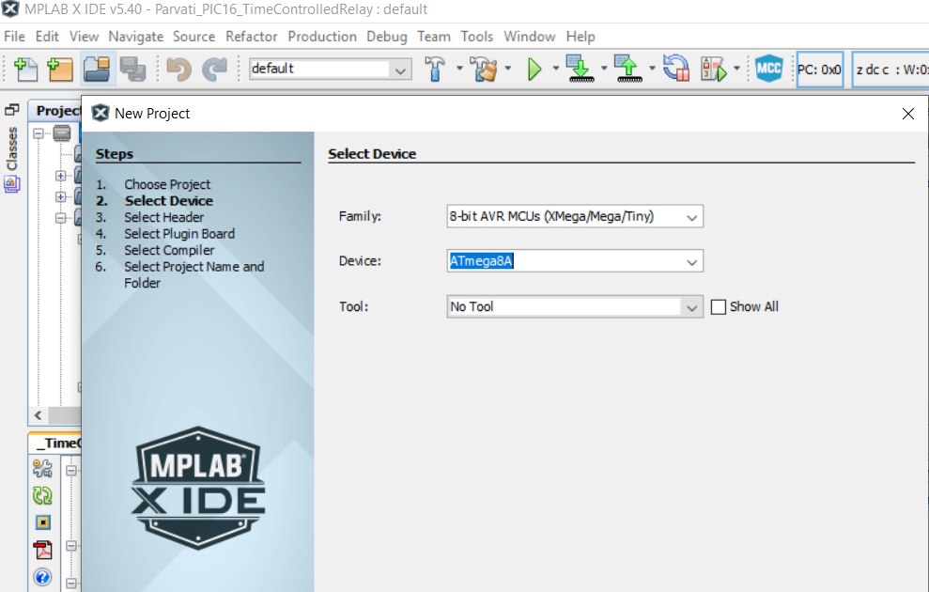

Proposed Software Design :

NO

Display 0 On display

Is Weight More than 0?

YES

Display Weight On LCD

Average the read counts with to get precise data

Read ADC